RESOLUTION NO.__________

RE: CERTIFICATE OF APPROPRIATENESS UNDER THE
PROVISIONS OF THE ACT OF THE PENNSYLVANIA
LEGISLATURE 1961, JUNE 13, P.L. 282 (53
SECTION 8004) AND BETHLEHEM ORDINANCE NO.
3952 AS AMENDED.

WHEREAS, it is proposed to revise COA to allow total demolition of the building because of foundation conditions at 215 Broadway (the building next to Broadway Social).

NOW, THEREFORE, BE IT RESOLVED by the Council of the City of Bethlehem that a Certificate of Appropriateness is hereby granted for the work.

Sponsored by: (s)

(s)

ADOPTED BY COUNCIL THIS DAY OF

(s)
President of Council

ATTEST:

(s)
City Clerk

HISTORIC CONSERVATION COMMISSION

CASE # 627– It is proposed to revise COA to allow total demolition of the building because of foundation conditions at 215 Broadway (the building next to Broadway Social).
OWNER/APPLICANT: Greg Salomoni

The Commission upon motion by Mr. Lader seconded by Ms. Starbuck adopted the proposal that City Council issue a Certificate of Appropriateness for the proposed work described herein:

- The proposal to revise the existing COA to allow total demolition of the building because of foundation conditions at 215 Broadway (the building next to Broadway Social) was represented by John Lee and Greg Salomoni.
- The building may be fully demolished with the following conditions:
- Scaled drawings will be created to document the existing cast stone architectural elements in case any are not able to be salvaged.
- All cast stone or stone architectural elements and as much historic brick as possible will be salvaged and reused in the new facades.
- The new front and side facades will match the drawings as submitted and amended in the May 2017 approval.
- New foundation plans for the building must be submitted prior to demolition.
- The applicants must return to the October HCC Meeting with revised façade drawings for the building.

- The motion to approve the proposal was approved by a 6-1 vote. Mr. Cornish voted against the proposal because he thought submission materials were not complete and because he was not at the earlier meeting when the partial demolition was approved.

CU: cu
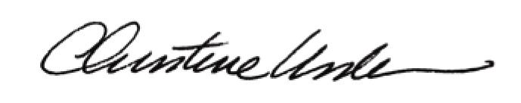

By:

Date of Meeting: September 18, 2017 Title: Historic Officer

